Theoretical neuroscience: Conditional probability and signal-detection theory
Date: 19/12/19
Names: Cormac Collins, Claudia Gonzalez, Nicole D’Souza

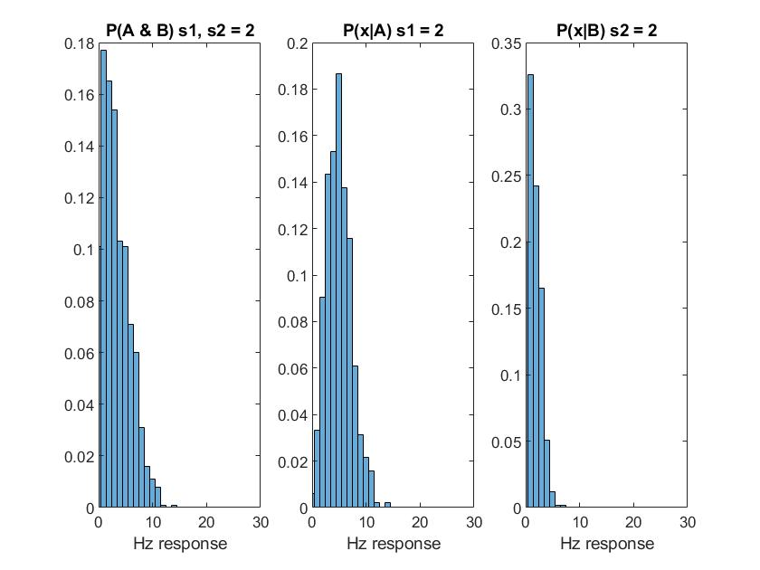

Figure 1: Neuronal probability responses to Stimulus Type A (Strength = 2) & Stimulus Type B (Strength = 2), 1000 trials.

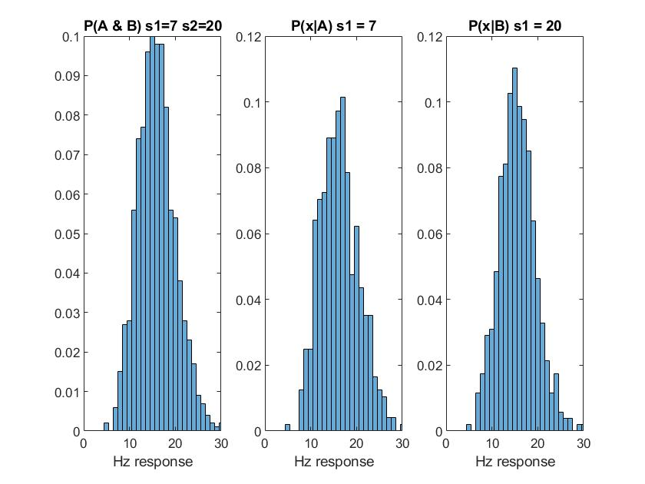
Figure 2: Neuronal probability responses to Stimulus Type A (Strength = 7) & Stimulus Type B (Strength = 20), 1000 trials.

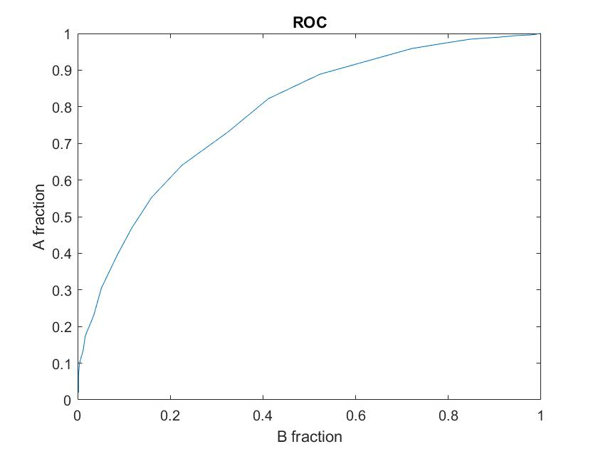
Figure 3: ROC curve for P(x| A) against P(x|B).

'reliability (fraction correct)' = -0.7783 (AUC of above graph)

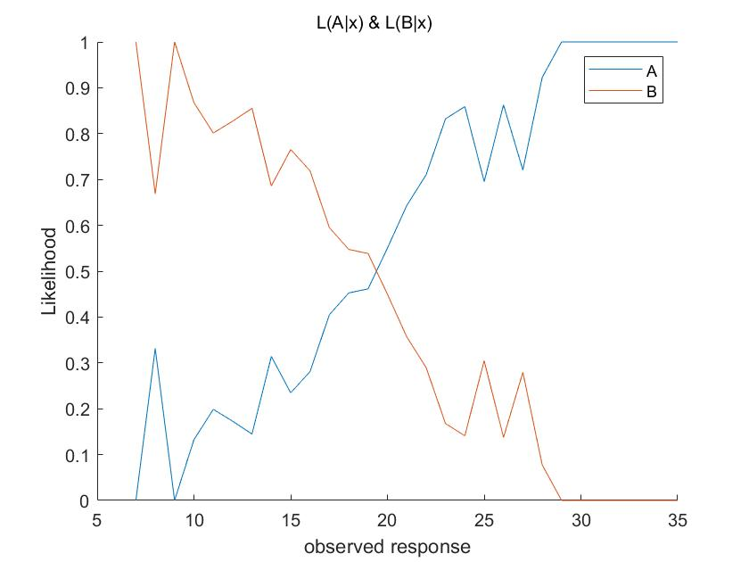

Figure 4: Likelihood of stimulus A or B, given an observed response.

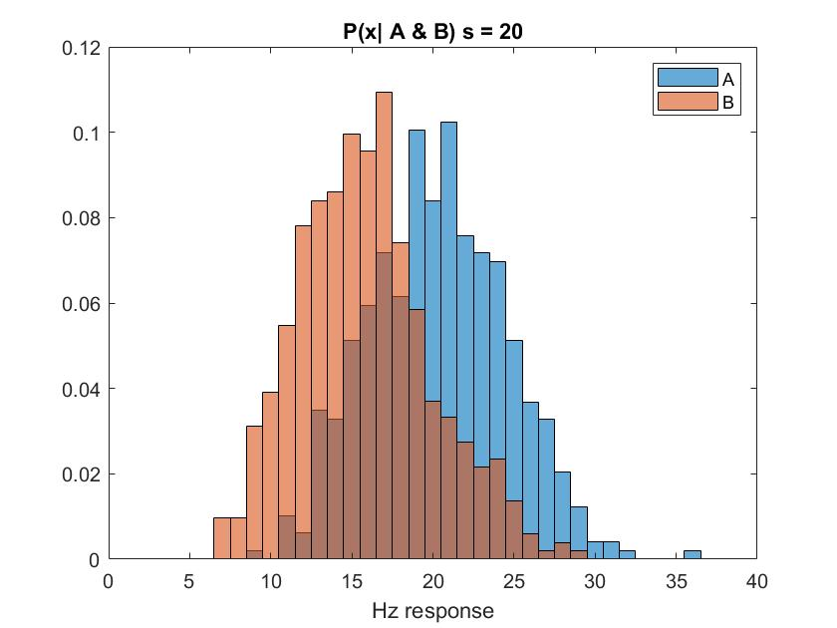

Figure 5 (Extra): Combined probability distributions for x response given A & B.

